DAA EXPERIMENT -4

NAME: KODALI SAHITH
ROLL NO: CH.SC.U4CSE24223
SECTION: CSE-C
DATE: 14-12-2025

- Merge Sort:

CODE:

#include <stdio.h>

void merge(int arr[], int l, int m, int r) {
int i, j, k;
int n1 = m - l + 1;
int n2 = r - m;

int L[50], R[50];

for(i = 0; i < n1; i++)
L[i] = arr[l + i];

for(j = 0; j < n2; j++)
R[j] = arr[m + 1 + j];

i = 0;
j = 0;
k = l;

while(i < n1 && j < n2) {
if(L[i] <= R[j]) {
arr[k] = L[i];
i++;
} else {
arr[k] = R[j];
j++;
}
k++;
}

while(i < n1) {
arr[k] = L[i];
i++;
k++;
}

while(j < n2) {
arr[k] = R[j];
j++;
k++;
}
}

void mergeSort(int arr[], int l, int r) {
if(l < r) {
int m = (l + r) / 2;

mergeSort(arr, l, m);
mergeSort(arr, m + 1, r);

merge(arr, l, m, r);
}
}

int main() {
int arr[100], n, i;

printf("Enter number of elements: ");
scanf("%d", &n);

printf("Enter elements:\n");
for(i = 0; i < n; i++)
scanf("%d", &arr[i]);

mergeSort(arr, 0, n - 1);

printf("Sorted array:\n");
for(i = 0; i < n; i++)
printf("%d ", arr[i]);

printf("\n");
return 0;
}

OUTPUT:

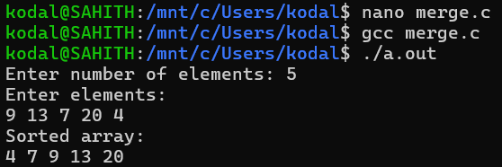

- Quick Sort:

CODE:

#include <stdio.h>

int partition(int arr[], int low, int high) {
int pivot = arr[high];
int i = low - 1;
int j, temp;

for(j = low; j < high; j++) {
if(arr[j] < pivot) {
i++;
temp = arr[i];
arr[i] = arr[j];
arr[j] = temp;
}
}

temp = arr[i + 1];
arr[i + 1] = arr[high];
arr[high] = temp;

return i + 1;
}

void quickSort(int arr[], int low, int high) {
if(low < high) {
int pi = partition(arr, low, high);

quickSort(arr, low, pi - 1);
quickSort(arr, pi + 1, high);
}
}

int main() {
int arr[100], n, i;

printf("Enter number of elements: ");
scanf("%d", &n);

printf("Enter elements:\n");
for(i = 0; i < n; i++)
scanf("%d", &arr[i]);

quickSort(arr, 0, n - 1);

printf("Sorted array:\n");
for(i = 0; i < n; i++)
printf("%d ", arr[i]);

printf("\n");
return 0;
}

OUTPUT:

